# Lesson 07 – Introduction to AJAX with JQuery

# Session 1 Worksheet

* Resources: <https://www.w3schools.com/js/js_ajax_intro.asp>
* <http://en.wikipedia.org/wiki/JSON>

Setup

1. Download *C273_L07Ajax.zip* from LEO. Save and extract it to C:\xampp\htdocs\C273_L07Ajax\.
2. Start NetBeans. Create a PHP Project with Existing Source that points to above folder.
3. Start the XAMPP Control Panel, and **start both the Apache and MySQL component**.
4. Type <http://localhost/phpmyadmin> on your browser to open PHPMyAdmin.
5. Create database **c273_p07**. Import the file **c273_p07.sql** into that database. You should have the table **flowers and flower_categories** under the database.

## Exercise 1a:

Inside C273_L07Ajax, create a new PHP file called "1a_getFruit.php" and type the following php code:

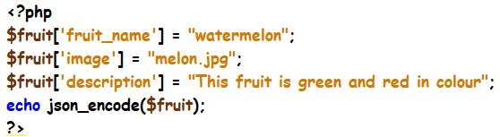

Run it and you should get an output that looks like this:



## Exercise 1b:

Create a PHP file called 1b_getColour.php that displays a random colour from 4 colours “Orange”, “Green”, “Blue” and “Yellow” and also the current date. A sample JSON response:



**Hint:**

* See <https://www.w3schools.com/php/php_date.asp>
* See <https://www.w3schools.com/php/func_math_mt_rand.asp>

## Exercise 1c:

Create a PHP file called 1c_getCircleResults.php that calculates the area of a circle (area = 3.142 x radius x radius) given the radius as a parameter.

A sample request to this webservice: <http://localhost/C273_L07Ajax/1c_getCircleResults.php?radius=5> will produce the following JSON response:



**Hint:** Use $_GET to retrieve the radius parameter <https://www.formget.com/php-post-get/>

In the same file, amend the code to receive another parameter “type”. If the type is “area”, calculate the area of a circle, otherwise if the type is “circumference” calculate the circumference of a circle (3.142 x 2 x radius)

A sample request to this webservice: <http://localhost/C273_L07Ajax/1c_getCircleResults.php?radius=5&type=circumference> will produce the following JSON response:



## Exercise 1d:

Create a PHP file called 1d_getCalorieResults.php.

* Receive 4 parameters “age”, “gender”, “height” and “weight”.
* Calculate the calorie per day using the BMR formula below:

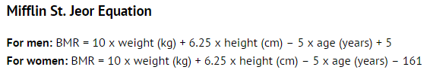

Test <http://localhost/C273_L07Ajax/1d_getCalorieResults.php?age=21&gender=M&height=170&weight=65> from your browser and you should get the JSON response:



|  |  |
| --- | --- |
|  |  |

## Exercise 2a:

Create a PHP file called 2a_getCategories.php that retrieves the data from the database table **flower_categories** and display the JSON response.

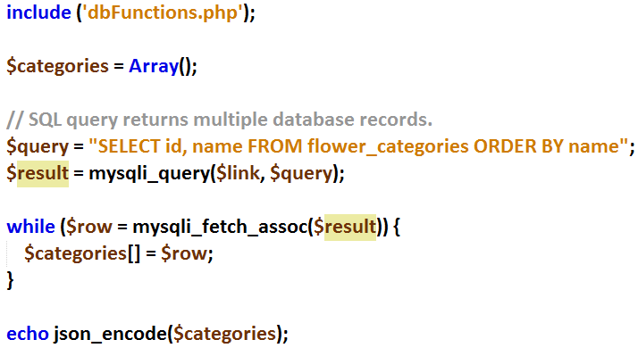

Test that it works by executing <http://localhost/C273_L07Ajax/2a_getCategories.php>

You can use an Online JSON viewer: <http://jsonviewer.stack.hu/> to check the structure of your JSON message. Copy and paste the JSON message on the “Text” tab and click on “Viewer” to see the structure.

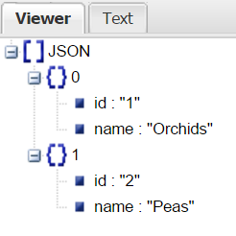

## Exercise 2b

Create a PHP file called 2b_getFlowers.php

* Retrieve data from the database table flowers for the category
* use $_GET to extract the cat_id from the Http GET request URL.
* Test getFlowers.php webservice by executing the following:

<http://localhost/C273_L07Ajax/2b_getFlowers.php?cat_id=1>

You should get the following output:



## Exercise 2c

Create a PHP file called 2c_getFlowerDetails.php

* Retrieve data from the database table flowers for the particular flower
* use $_GET to extract the f_id from the Http GET request URL.
* Test getFlowerDetail.php webservice by executing the following:

<http://localhost/C273_L07Ajax/2c_getFlowerDetails.php?f_id=1>

You should get the following JSON response:

